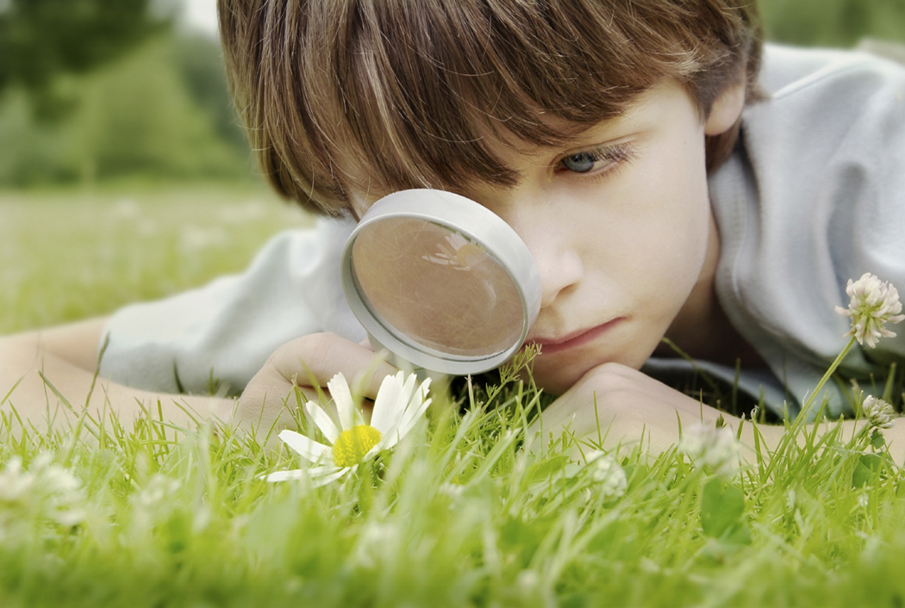
This is Dylan looking for bugs in the park!
What is important to Dylan?
- Dylan lives with mum, dad and his brothers Kyle (10) and Stuart (2) .
- He likes making tracks for his trains to go on.
- Dylan is really interested in counting at the moment- he counts to about 12 before getting in a muddle with the numbers
- Dylan loves playing football with his dad.
- Dylan’s friends are: Sam, Ahmed, Chloe, baby Luke, and Rachel.
- Dylan has a very special rabbit called 'Hoppy'. He takes 'Hoppy' to bed every night and carries it around when he is tired.
- Having a bedtime story. His favourite story is 'Whatever Next!'
- His favourite Cbeebies character is 'Sportacus'.

Who will collect Dylan from Nursery?
Mum (Mary) Dad (Jack) Nanna Rose (on Wednesday) Grandpa Joe (sometimes)
What do you need to know to look after Dylan?

- He has Asthma- he uses Ventolin.
- He is not keen on most vegetables but we want him to eat more and try to encourage him.
- He loves carrots!
- He is afraid if people wear masks or pretend to be 'wicked' characters.
- He usually sleeps for 30 mins after his lunch.
- He likes cuddles and his 'Hoppy' calms him down.
- He loves being tickled under his arms and his big brother always makes him laugh by singing silly songs.
- Dylan is really excited about school. If he does feel upset on his first day, talk to him about his brothers who both attend Latchmere.
- Dylan prefers to watch others before 'having a go' at things himself but he loves stories and will always join a small group to listen to a story.
What makes Dylan so special to us?
- Dylan is always happy in the morning and greets us with a huge smile
- He is really good at playing with his brothers.
- He gets very involved when playing with his favourite toys.
- His cuddles.
- He is always asking questions!

