Customising your child’s poster

The idea of this poster is for you to tell us as much as you want to about your child. This will help us get to know your child and understand what they need to feel cared for at school.

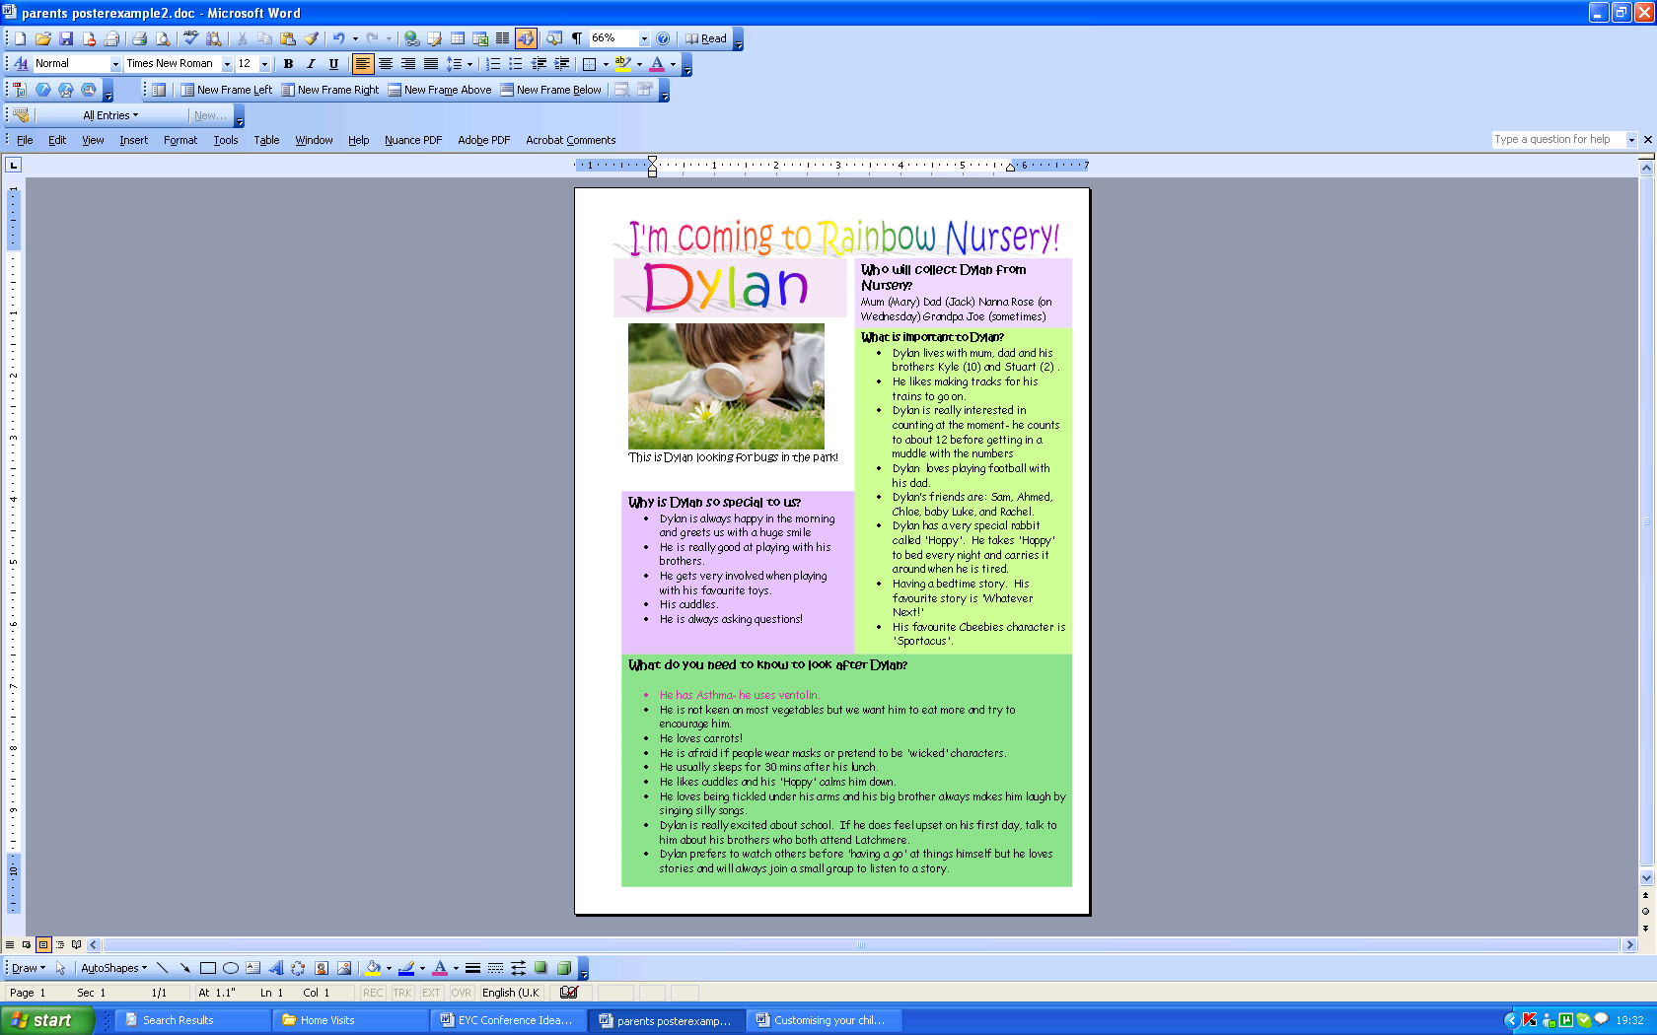
Please customise your poster in any way you like. Talk to your child about what should go in it too. You can change the colours and fonts to suit your child. When you have finished you can e-mail it back to school.
Delete the writing from this box.
Click Insert from top menu, then choose picture and from a file to access your pictures. Insert a picture of your child.
Or stick one on afterwards!

If you get stuck………..

e-mail:
nursery@latchmereschool.org

Please write: “help me with my poster” as the subject

or: “finished my poster” as the subject when you are e-mailing the final copy.

Delete any of the bullet points you don’t need.
To add more bullet points just press return/enter after you have written in the bottom one.

Double click on the writing to change it to your child’s name. You can also change the font type and colour here.
Right click on the text box to change the colour. Select 'format text box'. Select 'colours and lines' tab. Click 'drop down' arrow next to 'fill'. Choose your new colour.

Highlight writing and type over the top of it to change it.

